**Day 44**

**What to do?**

Learn about padding and strides. And learn how different padding and stride values affect the network.

**Padding:**

As seen before, padding is the process of adding extra layers of border to the image, like below.

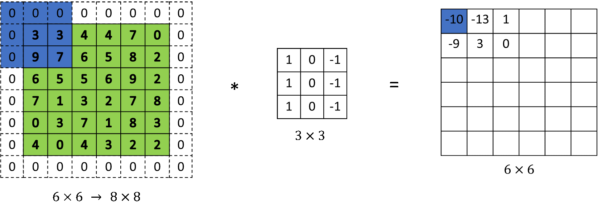

If the above image does not have pads, then the output would be of size 4 x 4. In other words, input without padding that undergoes convolution, shrinks the output. As you perform more convolutions, i.e. without padding, final output may even shrink to 1 x 1, which is throwing a whole lot of information. With padding, however, the output could be the same shape as input.

Hence, there are two types of convolution or methods on how much to pad.

1. Valid convolution:

Valid = no padding. Formula: (n x n) * (f x f) = (n – f + 1) x (n – f + 1)

1. Same convolution:

Same = input size is the same as output size by adding padding. Formula: (n x n) with padding p * (f x f) = (n + 2p – f + 1) x (n + 2p – f + 1). Hence, p value should be p = (f – 1)/2

**Stride:**

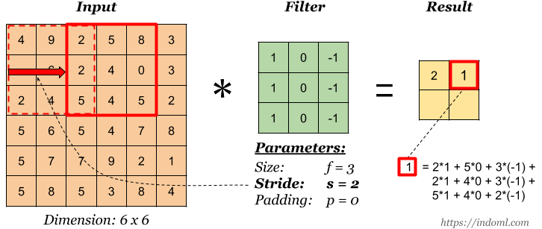

While padding is used to not shrink the output, stride is used to down sample the size of the output. By default, stride is 1. The filter is moved across the image left to right, top to bottom with one – pixel column change both vertically and horizontally. In the above image, stride is 2. It means that, instead of convoluting 9 2 5 6 2 4 4 5 4, the filter convolutes 2 5 8 2 4 0 5 4 5. Vertically, it skips 2nd row and calculates from 3rd row.

The output size when there is no padding (p = 0) and stride s is,

(n x n) with p = 0 * (f x f) with stride s = ((n + 2p – f)/s + 1) x ((n + 2p – f)/s + 1)